**Ellicottville Central School**

**Smart Schools Investment Plan**

**Classroom Technology & Security**

**January 2016**

### *Shawne Hunt*

***District Technology Facilitator***

***Ellicottville Central School***

***5873 Rt 219***

***Ellicottville, NY 14731***

***(716) 699-5034***

***Fax: (716) 699-5423***

[***shunt@eville.wnyric.org***](mailto:shunt@eville.wnyric.org)

# ACKNOWLEDGEMENTS

This Smart Schools Investment Plan was made possible by the support, cooperation and dedication of many members of the school community:

**The Ellicottville Central School Board of Education -** whose ongoing approval and support have made the implementation of technology education at Ellicottville Central School a success.

**The Ellicottville Central School Faculty –** members who have accepted the challenge of implementing the constantly changing technology as well as offering their concerns and suggestions by completing the surveys upon which this plan is based.

**The Ellicottville Central School Smart Schools Committee,** an ongoing committee dedicated to research and implementation of technology in all phases of our curriculum. Stakeholders include:

Mark Ward, Superintendent

Bob Miller, MS/HS Principal

Connie Poulin, Elementary Principal

Bill Murphy, School Board Member/Parent

Roger Spell, School Board Member/Parent

Alice Alessi, Speech Therapist

Ann Chamberlain, Mathematics

April Donoghue, 3rd Grade

Chris Edwards, Technology

Helena Brierton, Science

Pam Illig, Library Media Specialist

Shawne Hunt, District Technology Facilitator

Bill Bacon, Community Member

John Pfeffer, Parent

Eli DeChane, Student

Kaleigh Hunt, Student

Wil Timkey, Student

**Technology Mission Statement**

Ellicottville Central School will guarantee that all students will achieve their highest level of competence through a success-oriented education that will ensure quality graduates.

**Technology Vision**

The learning community at ECS will be technologically aware and literate life-long learners who are challenged to reach beyond the current technologies to achieve personal, educational and workplace goals.

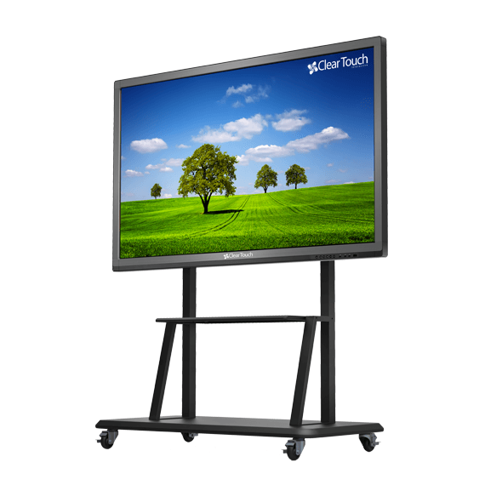

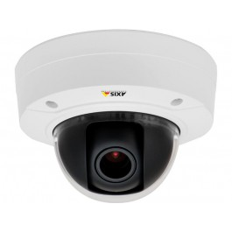

**Technology Mission and Goals**

The technology mission of Ellicottville Central School is to provide this education with the aid of technology that will accomplish the following goals:

**Goal #1 – ECS will have staff and students that are technologically literate.**

* Enhance the development of the whole child through a dynamic technologically integrated curriculum that encourages exploration and life-long learning.
* Utilize technology in an active, student-centered learning environment to enhance problem solving, critical thinking and collaboration skills.
* Enhance present teaching styles and creative management through ongoing staff development.

**Goal #2 –**

* Promote the utilization of technology for communication and information retrieval.

**Goal #3 -**

* Provide up-to-date network infrastructure and equipment to meet the needs of all stakeholders in the District.

**Goal #4 –**

* Prepare students for today’s workplace and the workplace of the future. We have a large population of students that are not served with high speed internet at their homes, therefore many students rely on school for their internet usage.

**Goal #5 -**

* Maintain and update technology use guidelines and procedures to address emerging technologies and changes in District policy.

**Goal #6 –**

* Maintain a server room with current equipment to meet the curricular and administrative needs of the District.

**Classroom Technology**

The Ellicottville Central School District (ECSD) will use approximately $200,000 of the Smart Schools Bond Act funds allocated to ECSD ($343,647) to purchase ClearTouch Interactive Boards for every classroom in the District. This 70″ LCD offers 10 points of touch, an optional integrated PC running Windows 8.1, and plenty of ports to plug in any peripherals required within the classroom.  This one product will combine the Interactive Board, TV and Projector all into one unit.

**ECS Instructional Technology Plan**

ECS plans on using the above mentioned technology to fulfill the action plans previously submitted to NYSED. The integration and use of technology as an instructional tool and resource will continue to be encouraged in all academic areas. Providing the administrators, teachers, staff, and students with the best tools available will enable them to perform their respective tasks more effectively and productively. In addition to the rich academic preparation the students will receive in each subject area, they will also become more aware of the technology tools available to support information access, analysis, synthesis, management, and communication. The school district will use these interactive boards along with the Internet and distance learning to improve student learning outcomes by delivering learning “resources” unavailable otherwise. Technology will be integrated into curriculum and learning activities aimed at improved student learning and attainment of the New York State content and performance standards.

**Students with Disabilities**

These interactive boards will be used to promote the varied types of learning as well as learning styles and abilities present in our classrooms. Software selected for instructional purposes that will be used on these boards must take into consideration curriculum goals, teaching styles at the various levels, and learning styles and abilities of all students.

**Technology and Infrastructure Inventory**

The current technology infrastructure will support adding on these interactive panels. We currently purchase our primary internet access bandwidth services from Erie 1 BOCES. The currentnetwork broadband bandwidthfor incomingconnection TO our school district (WAN) is a 1GB connection. The currentnetwork broadband bandwidth for connections WITHIN our school district (LAN) is a 2GB connection. The following wireless protocols are available in the district: 802.11a, 802.11g, 802.11n, 802.11ac, 802.11ad and 802.11af. Currently 100% of our instructional space has wireless coverage provided by wireless access points. We use a wireless controller and the port speed of our switches is 1GB.

**Professional Development**

The Ellicottville Central School, through its Professional Performance Review Plan, will strive to assist all professional personnel (professional personnel /nurse /assistants) in acquiring the knowledge and skills needed to help each student pursue their full potential as life-long learners and respectful citizens. The following premises are used in the Professional Performance Review of all professional personnel:

Effective teaching and successful learning occur when professional personnel are skilled in employing a variety of strategies, management techniques and assessments and share the information with students and other professionals.

1. Effective teaching and successful learning occur when professional personnel are skilled in employing a variety of strategies, management techniques and assessments and share the information with students and other professionals.

2. Conduct is an ongoing dedication to the education process within the classroom and in support of the learning environment.

3. Demonstrates professional growth in a variety of ways.

4. Promotes and exhibits care for the facilities and the place our school has in the community.

5. Reflect on their performance to improve student achievement.

The Ellicottville Central School District and the Ellicottville Teacher’s Association recognize that we are engaged in a common enterprise and that we have a shared commitment both to improving the quality of teaching and learning and to the educational success of each student. Teacher training and professional development in technology play a key role in its ultimate acceptance and use in the classroom. Research indicates technology planning must address comprehensive and continuous professional development to ensure success. Multiple levels of training and staff development must be offered to teachers and administrators so they feel empowered to use technology to facilitate their own productivity.

The availability of diverse professional development opportunities is important to address the needs of all staff within the district; however, this spectrum of diversity should be orchestrated to move all staff toward common goals. Technology-related professional development requires curriculum integration skills, as well as operational and technical skills. Professional development programs prepare the teaching staff to effectively deliver integration of content objectives, process skills, and technology competencies appropriate to the grade level, subject area, and/or course in which students are engaged. Successful integration will require more specific definition of those elements to be integrated. Curriculum in some areas will need upgrading to identify the basic information, performance standards, and technology linkages that education reform priorities dictate as essential outcomes for students.

Goals for Staff usage of telecommunications and information technology to improve student academic achievement include:

• To become familiar with multimedia presentation software and interactive whiteboards as a priority teaching/learning technique.

• Develop K-12 aligned & articulated curriculum in all content areas using EngageNY.

• Improve external communication.

• Improve internal communication.

• Having a technology integrated curriculum.

• Stay up to date on the latest technology.

School district staff members now participate in a variety of professional development programs sponsored by the BOCES and/or the district. In addition to improved and expanded professional development provided directly from the BOCES, services are provided linking other professional development resources such as colleges and universities, nonprofit agencies, government agencies and businesses including:

*Alfred State *Alfred University *Buffalo State *SUNY at Buffalo

*ECC *GCC *Houghton College *JCC

*Erie #1 BOCES *Erie #2 BOCES *Southern Tier West

*NYS VESID *Apple Computer *ClearTouch *CA BOCES

In reference to the new interactive boards, the Technology Coordinator and the AV Coordinator will be responsible for training the teachers on use and maintenance. The life span of these boards is estimated to be 40,000+ hours of instruction (over 20 years of classroom use). When end of life occurs, the Ellicottville Central School District will reevaluate the latest technologies and come up with a replacement plan.



**Security**

The Ellicottville Central School District (ECSD) will use approximately $115,000 of the Smart Schools Bond Act funds allocated to ECSD ($343,647) to purchase Security cameras, a server and software to add to our current system.

The District currently has 22 security cameras connected to an HP server running AirVision software. This current system is not sufficient to give the District adequate coverage which is required in current times. We plan on purchasing 75 networked cameras to replace and add to our current system. Our network is already segmented to allow cameras to run simultaneously with our data network to prevent slowdowns or network lags.

The District will take the recommendation from our WNYRIC (Erie 1 BOCES) to obtain the Milestone software and licensing for the specified cameras. Erie 1 BOCES will also help monitor our server as well as all cameras on the network.

The District believes this will add a missing security component to the Ellicottville Central School District to help ensure the safety of our staff, students and guests.



